Condamine Alluvium Substitution Scheme
Expression of Interest form
Arrow Energy is seeking expressions of interest from landholders with Condamine Alluvium water licences who wish to participate in Arrow’s Condamine Alluvium Substitution Scheme (the Scheme).
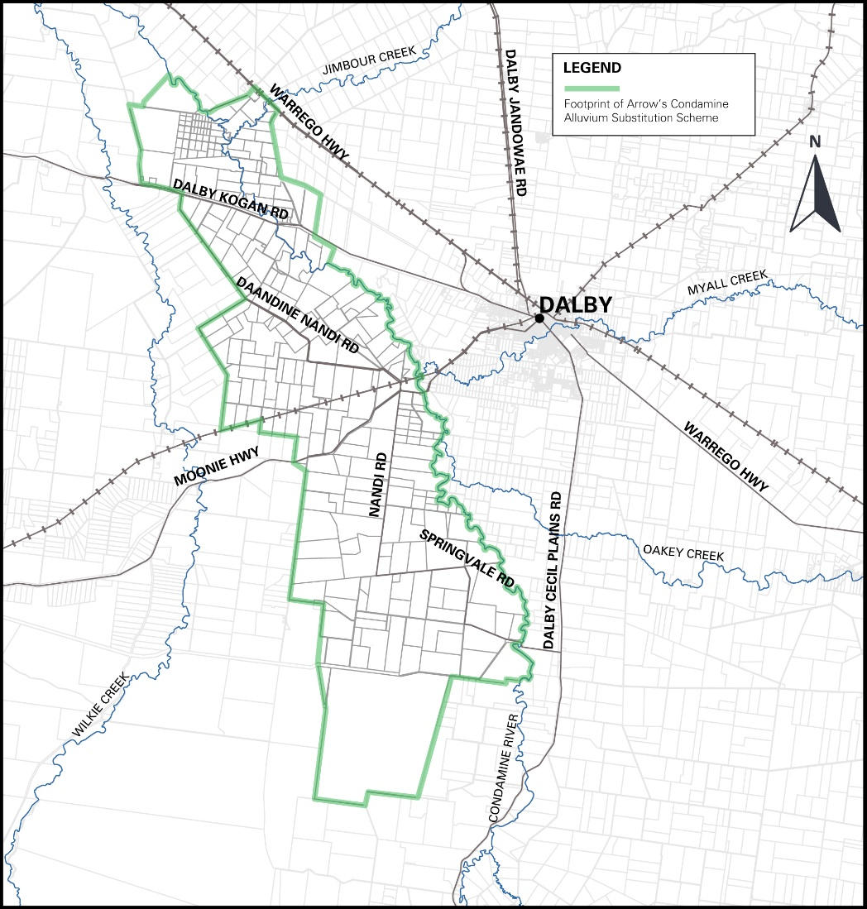
The scheme eligibility area

Eligible landholders must submit an expression of interest in participating in the scheme by 4:00pm Friday 10 September 2021.

Applicant details
Mr / Mrs / Ms / Miss (please circle)
Full name (First, Middle & Surname)

Company/Business Name (if applicable)
ABN | ACN

Street Address

Postal Address

Town/Suburb

Phone | Email

Details of landholder water bore(s)

Water bore registration number(s) from which you take water for these licences

Licensee name as shown on the water licence(s)

The water license(s) authorised/permitted purpose

Water licence(s)authorised volume (ML/year)

Please provide the total annual volume of water used from your bore over the past five years.

[Please attach a copy of the water licence for the water bore]

Volume of substitution water
Please confirm the volume of groundwater allocation that you would like to nominate to be substituted (e.g. this may not be your full licence volume):

Arrow may have to scale back applications in the event the scheme is oversubscribed or predicted water volumes reduce. In such an event, what would be the lowest volume of water you would accept?

75% 50% 25% No reduction would be accepted (please circle)

In the alternative, please indicate what the minimum volume of water you will accept as substitution for you to join the Scheme (ML/year)?

Your infrastructure
Please provide a brief description of your existing infrastructure (including dam capacity and location) and confirm that you have the ability to accept the water provided by Arrow on a daily basis.
[Please attach photos/maps of your existing infrastructure if applicable]

Acknowledgement
I/We declare the information supplied on this form to be true and correct.
I/We acknowledge that Arrow:
- will assess the feasibility of my/our EOI, in particular, the details of my/our water bore, water bore licence or water storages on our property;
- may contact me/us if information provided under “Details of landholder water bore”; Volume of substitution water” and “Your infrastructure” in this form are incomplete or unclear; and
- may use the contact details supplied in this form to contact me/us for clarification on any of the information supplied in this form.
This EOI does not guarantee I/we will be successful to be nominated to participate in the Scheme.
This EOI is to gauge interest in proceeding to a formal selection process and is not a binding agreement on you or on Arrow.
You will receive an email confirming that your EOI has been received.
Signature of Applicant | Date
Applicant Name (Print)

IMPORTANT – PLEASE READ
Your conduct throughout the Condamine Alluvium Substitution Scheme
Arrow’s Condamine Alluvium Substitution Scheme is a competitive process. Arrow kindly reminds you that as an applicant with an EOI for Arrow’s Condamine Alluvium Substitution Scheme, you must follow any strict competition law rules that apply before and after you submit this form - including ensuring that when you filled out the form and throughout the formal selection process, you acted and will continue to act independently and not in consultation or agreement with other landowners or water bore licence holders.
Arrow understands that you may have general discussions with industry bodies or groups about the Condamine Alluvium Substitution Scheme. If this applies to you, then those discussions must be preliminary in nature and is subject to your final decision. Whether you choose to participate in the Condamine Alluvium Substitution Scheme on the terms proposed by Arrow is entirely up to you, having regard to your own circumstances.
Privacy
Where Arrow is collecting personal information from you, it will use that information for the purpose of setting up the Condamine Alluvium Substitution Scheme Arrow’s dealings with your personal information will comply with applicable privacy laws and our privacy policy. Arrow will:
- take reasonable steps to ensure that the personal information it holds is protected against misuse, interference, loss, unauthorised access, unauthorised modification and unauthorised disclosure;
- ensure that only its officers, employees, agents, contractors and consultants who have a need to deal with personal information in connection with the scheme are given access, and only use the personal information for the purposes of the scheme program and are aware of, and comply with the applicable privacy laws and our privacy policy; and
- immediately notify you if it becomes aware of a breach or possible breach of its obligations in relation to the personal information, and will immediately take such steps as is necessary to resolve or otherwise deal with the breach or possible breach.
For further information about Arrow’s privacy policy, please visit: https://www.arrowenergy.com.au/privacy”
Lodgement information
Please email the completed form and any attachments by 4:00pm Friday 10 September 2021 to:
or send by post to:
Arrow Energy
GPO Box 5262
BRISBANE QLD 4001
If you have any questions about the scheme, please contact Arrow on 1800 038 856 (free call), or email info@arrowenergy.com.au

The Scheme is located in the area of greatest predicted impact to the Condamine Alluvium as identified by the Office of Groundwater Impact Assessment in multiple Surat Cumulative Area Underground Water Impact Reports.

